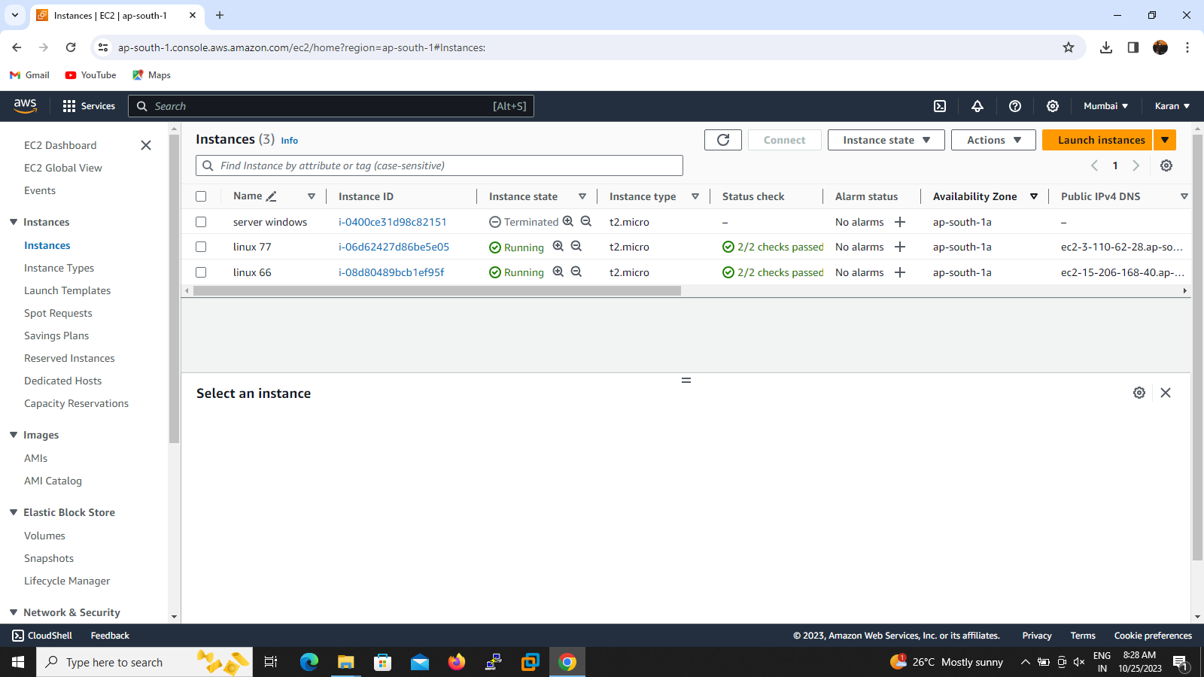

1.scenerio swap the volumes so we create two instance and detach from which instance .Now go to stop stop the two instance then detach the volume from instance

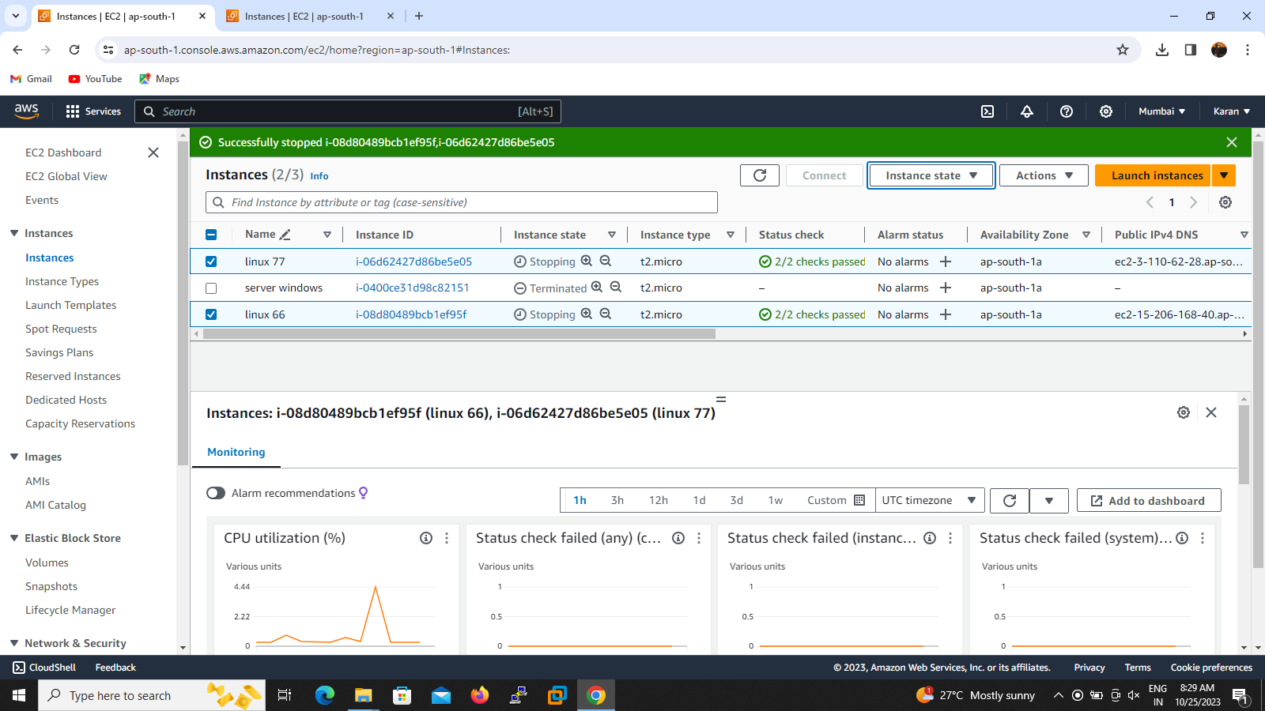

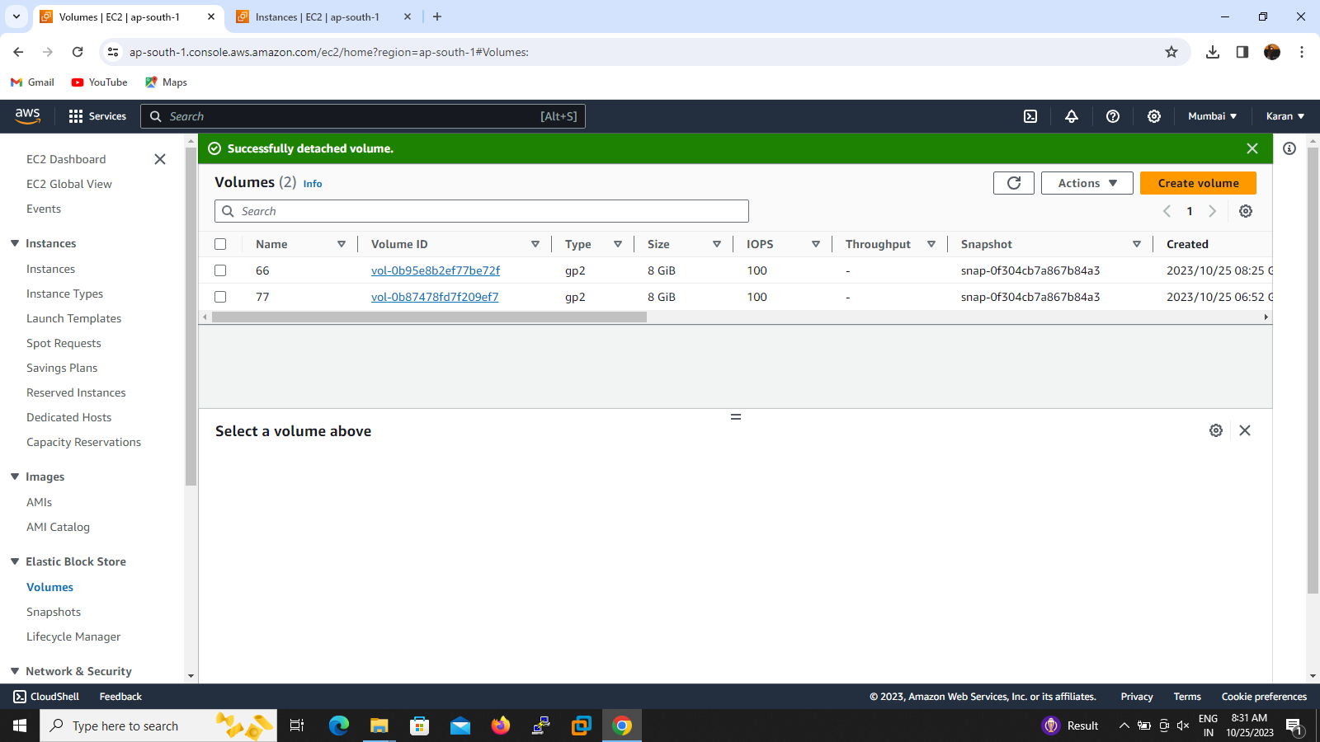

2.above screenshot shows detached successfully.Then we go to attach the voulume as per required instance right click on volume id then attach to required instance and storage path

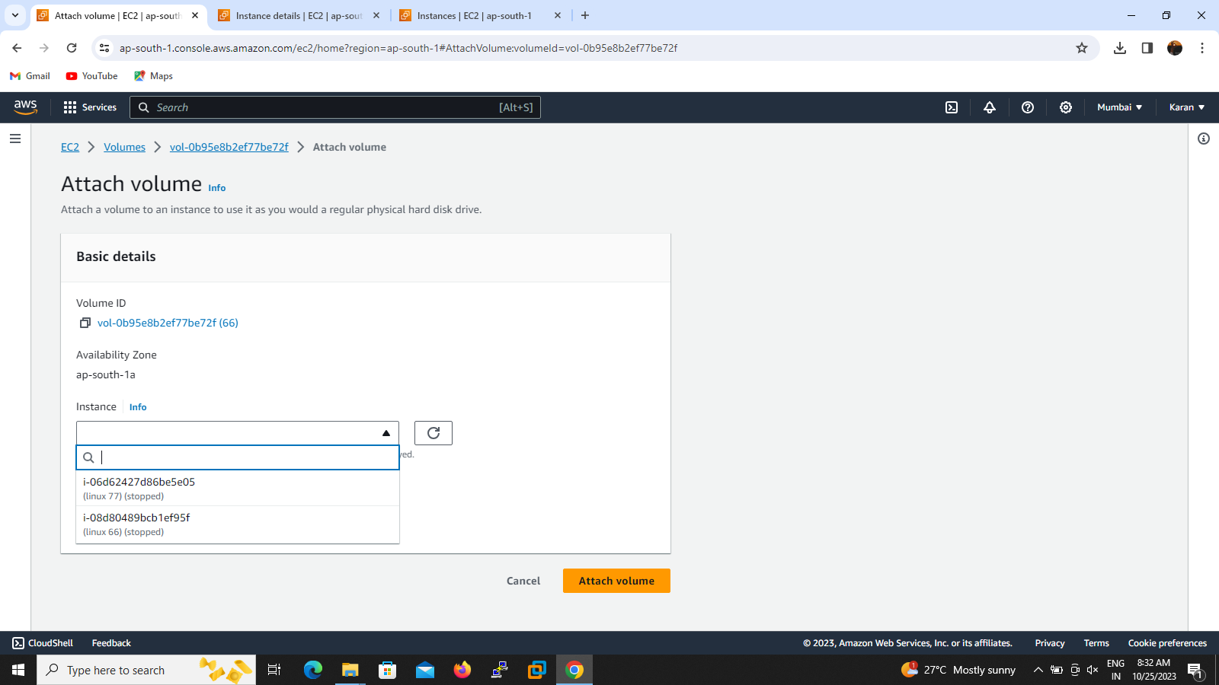

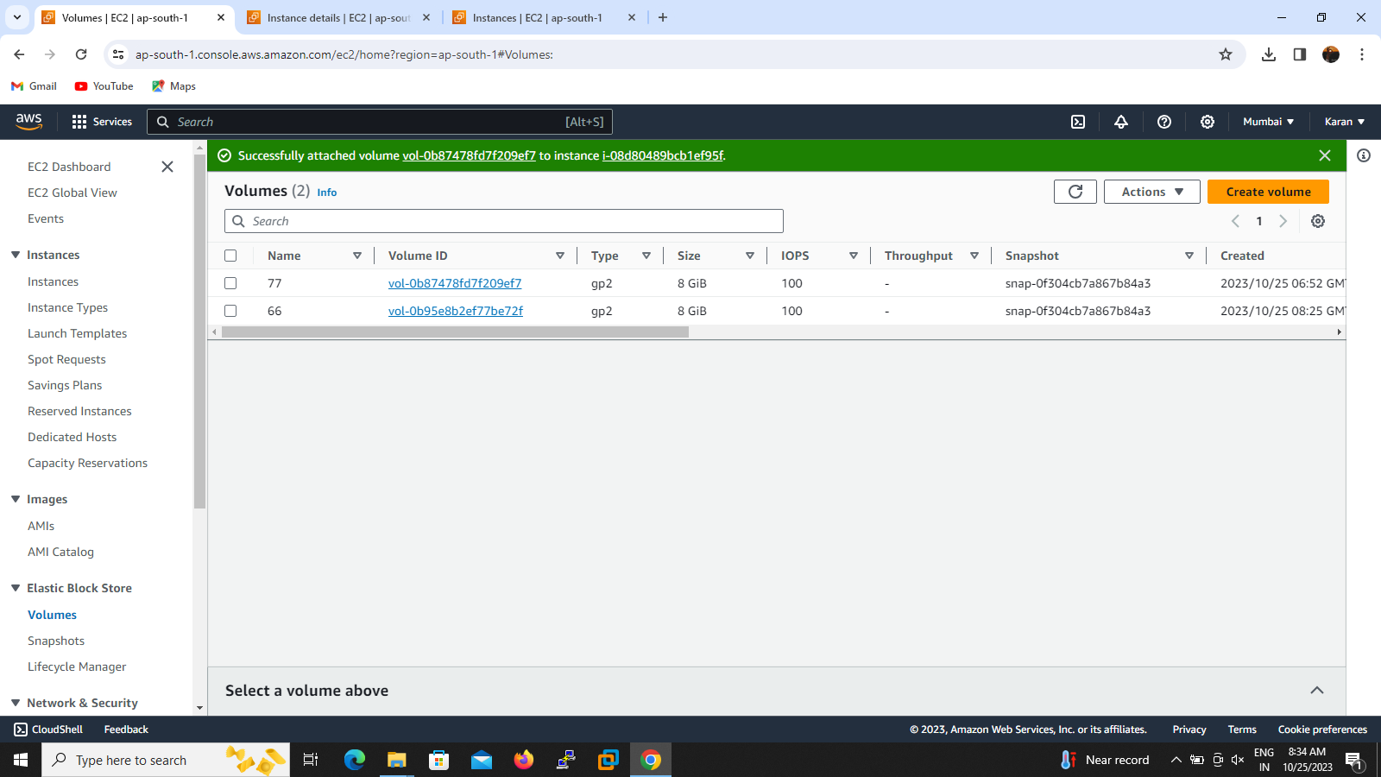

3.above screenshot shows volume attached to instance successfully without take snapshot

